**Help file for Propogold**

**Propogold** is a software, that helps those, who want to bet at a gambling, or prediction for some people, game called **Propogoal** and it is held in Greece. Let’s explain what is the aim of the game first.

Propogoal is a prediction’s game. Every weekend, the National Organisation of Football Predictions in Greece, gives a selected list of 30 football matches that are going to be in the competition.

The player who wants to play, has to predict the 8 matches that are going to be scored the most goals. Easy? Not at all.

Let’s suppose that we have to matches, A and B. In match A we have a final score of 3-0 and in match B we have a final score of 2-1. Which match joins the list of winning 8 matches?

Match B does, because the away team has scored. So rule nr 1 : “If two matches have the same sum of goals, winning match is the one that the away team has scored most goals”.

Therefore, it is logical that score 1-2 beats 2-1 and 0-3 beats all matches with a sum of goals equal to 3.

What happens now if match A has a score of 3-0 and match B also a score of 3-0?

Then, it depends at which position they stand, in the list of 30. If A stands at position 5 and B at position 29, then A goes in the winning list.

Winner is considered a player when he has at least 6 right predictions.

Let’s see an example of a drawn competition taken from the official site of the game:

<https://www.opap.gr/en/propogoal-draw-results>

**The software**

Some people would ask : “How can this software help me win?”. First we must do some calculations to see how possible it is to have 8 right predictions.

How many are the possible columns that come out of 30 matches? Columns is a set of 8 matches, for example [1,2,3,4,5,6,7,8] or [2,4,5,9,13,23,24,27] or [3,5,7,9,19,23,25,29].

All possible columns are (30*29*28*…*23) / (8*7*6*5…*1) = 5.852.925 columns. So, a single columns stands 1/5.852.925 to win the game.

Can we include all columns to win the game? Of course, but that would be stupid, we would have to spend more money to bet than the winnings. So, we have to reduce somehow the columns.

How can we reduce the columns? First, through **prediction**. Football is not like lottery. You can predict football. Well, not always, but sometimes you can. For example, if I have 2 matches, let’s say Man.City – Southampton and Man.United – Tottenham, I find it more possible that at the first match, it is most likely many goals to be scored, because of the offensive strength of Man.City. That means that I will have to leave out Man.United match.

**Statistics**

Every winning column, has some statistics that some people look at and then decide what to choose to play or not to play. For example, in column [1,3,5,13,20,22,24,28] there are 4 odd numbers and if ‘cut’ the list of 30 in half, I have also 4 matches under 16 and 4 numbers over 15. That is some statistics. One may ask “but the game has no memory. Next competition is independent from the previous one”. And he would be right. But we use statistics sometimes to see which statistic gives us the most possible combinations. For example, If I told you that a family has 4 children and you have to bet on a combination of [boys – girls], on which combination would you bet?[0 boys-4 girls], [1 boy – 3 girls],…etc ?

I would bet on [2 boys – 2 girls], because it is more likely to win the bet.

**Starting a new system**

First, we take a look at all matches and see how many we need to choose from the list of 30 matches. Let’s say we have chosen 18 matches out of 30 that we predict that the winning column will be among them. But, how many combinations are made from 18 matches?

Combinations : 43.758 = (18*17*16*15*14*13*12*11) / (8*7*…*1)

This will be called a **full system.** A full system is a system that it includes all possible columns without **conditions.** We don’t care about odd or even number, first or second half of the list.

But is it wise to choose all columns? No it is not, they are still too many. Now we will have to use our software.

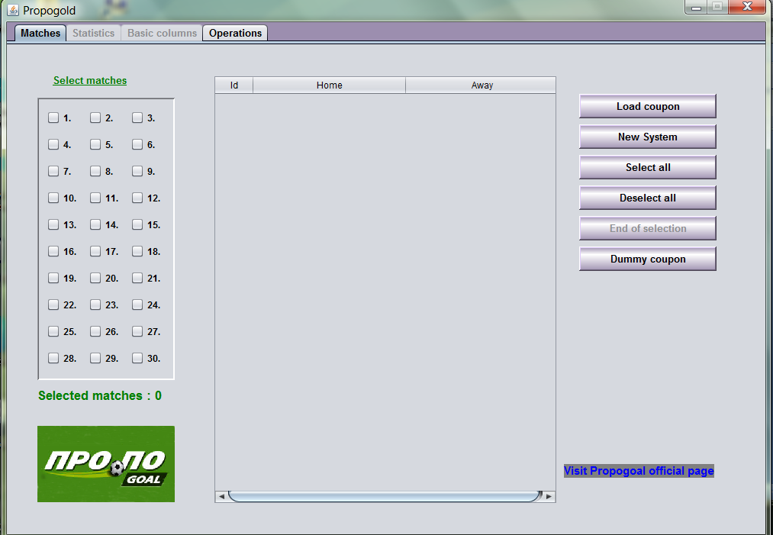

In the first screen we can select our matches, load the coupon (list of games) from the official internet page (unfortunately only in Greek language) or just use a coupon of fake matches by hitting Dummy Coupon button, just to practice.

We can alse select or deselect all games by just hitting the appropriate button.

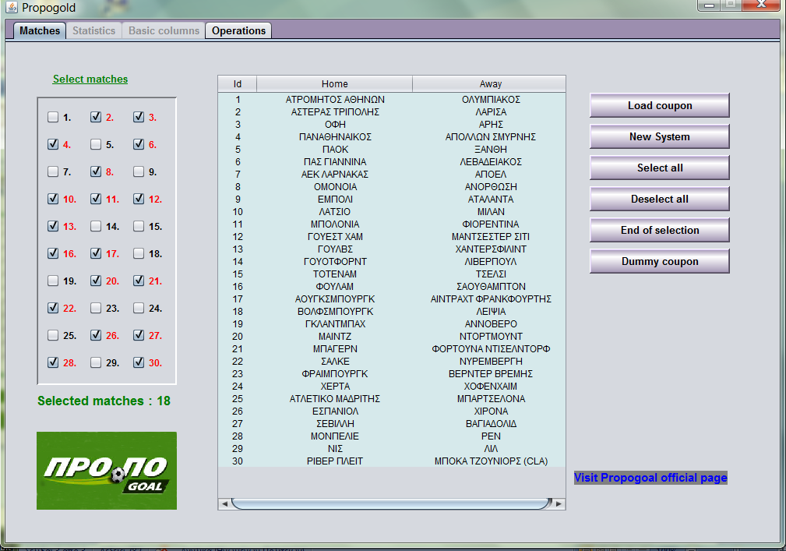

That is the next screen. We have loaded a coupon and selected matches 2,3,4,6,8,10,11,…,30. When we feel ready, we have to push “End of selection” button, to be able to use **Statistics** and **Basic Columns**.

Once we hit it, next panels are selectable. Let’s see what’s inside Statistics panel.

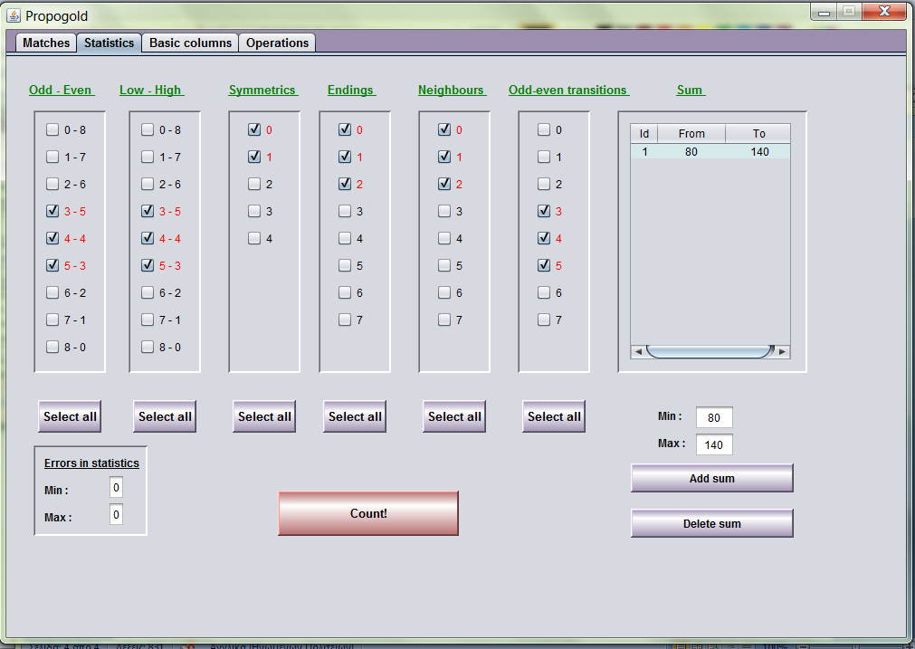

**Odd – even** : Choose how many odd or even numbers will be in the winning column.

**Low-high** : Choose how many <16 (low) or >15(high) numbers will be in the winning column.

**Symmetrics**: We call symmetry if the sum of 2 numbers is equal to 31. For example, 1 and 30 have a relationship of symmetry, 2 and 29 etc.

**Endings**: If two numbers end at the same digit. For example 2 and 12, 2 and 22 etc.

**Neighbours**: Easy to understand. If two numbers are neighbours, like 1 and 2, 4 and 5, 22 and 23 etc

**Odd-even transitions**: If we sort the winning column from low to high, how many transitions from odd to even or even to odd we have? For example, in column

[1,3,5,7,9,11,14,15] we have 2 transitions, 11-14 and 14-15.

**Sum :** The sum of the numbers of the winning column.

All those, are called conditions.

In the picture, we have selected 3-5 odd, 3-5 low, 0-1 symmetrics, 0-2 neighbours, 3-5 transitions and a sum of 80-140.

If we hit Count button, we get a result of 5589 columns. What that means is that we have decreased the amount of columns from 43758 to only 5589. If all conditions are met, then the winning column is in the 5589 columns.

If we feel uncertain, we may change the textboxes Errors in statistics and have values from 0-1 for example. That means of course that columns will be much more than 5589.

Next screen is Basic Columns. But what is a basic column?

A basic column is a column, that satisfies some conditions. For example let’s say that we have the matches of Man.City and Dortmund selected and we believe that **at least one** of them will be in the winning column.

Then we give a basic column with ids of the matches and we want 1-2 matches in the winning column. See the following picture:

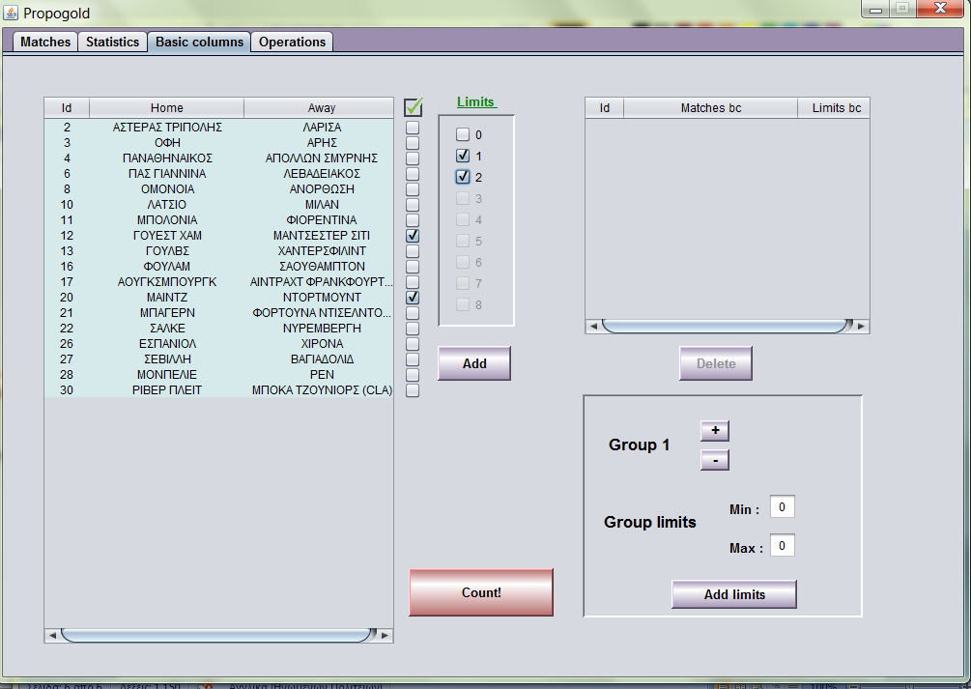

I have selected match 12 and match 20. Limits are 1-2. If I hit button “Add”, the basic column will be added in the table at the right. Of course I can add as many basic columns as I want and group them as I want and have group error limits.

But let’s see what happens if I hit count. How many columns have I managed to save? I now have only 2579 columns. That means I have saved about 3000 columns.

I will add some more basic columns, set their group error limits and hit again “Count”.

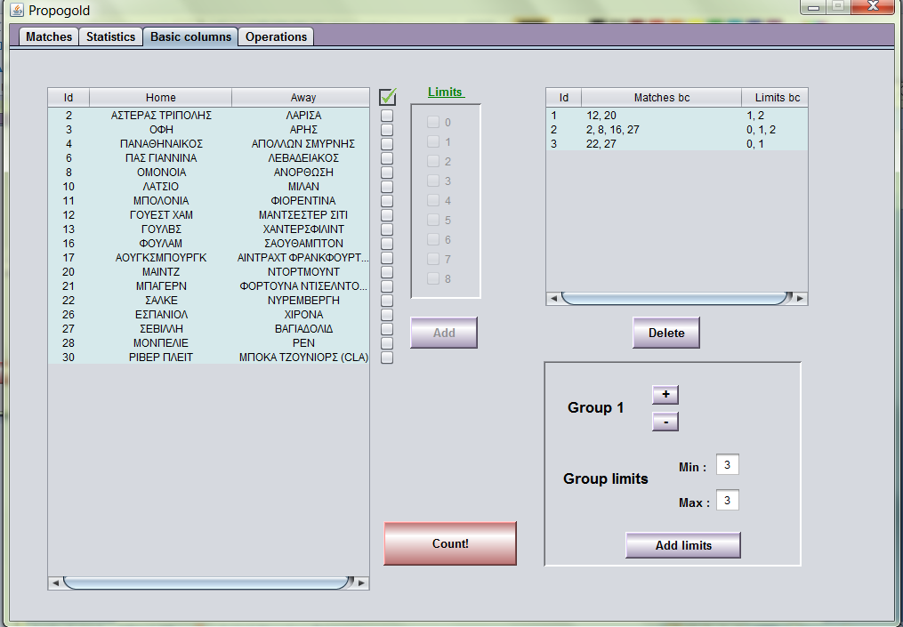

We have now 3 basic columns : [12,20] with 1-2 limits, [2,8,16,27] with 0,1,2 limits and [22,27] with 0-1 limits. Group limits are 3-3, that means that all of them have to be right in the end, in order to win.

If we hit “Count”, we get as result 2063 columns. We saved about 500 columns more, by adding 2 more basic columns.

Of course we may have as many groups as we want by clicking “ + “.

Let’s move to panel **Operations**.

In this panel, we may view columns, print columns to coupons, save the conditions to .doc file and most important, create a variable system.

But what is a variable system? A **variable system**, is a set of the full system that guarantees that it gives a 100% win, but in a lower category but with much less columns.

Example : We have selected matches [1,2,3,4,5,6,7,8,9]. That is 9 columns if we have all combinations:

[1,2,3,4,5,6,7,8]

[1,2,3,4,5,6,7,9]

[1,2,3,4,5,6,8,9]

[1,2,3,4,5,7,8,9]

[1,2,3,4,6,7,8,9]

[1,2,3,5,6,7,8,9]

[1,2,4,5,6,7,8,9]

[1,3,4,5,6,7,8,9]

[2,3,4,5,6,7,8,9]

But is there a minimum set of that, that guarantees that I get at least 7 right predicted, if my full system gets 8 right predicted?

Of course there is, and it is a set of just 1 column. That means that I have saved 90% of the columns and there is also a chance of 11% to win the first category winnings.

Assume that we have selected 12 matches, 1-12.

This is in fully, 495 columns. Let’s try the variable calculating algorithm:

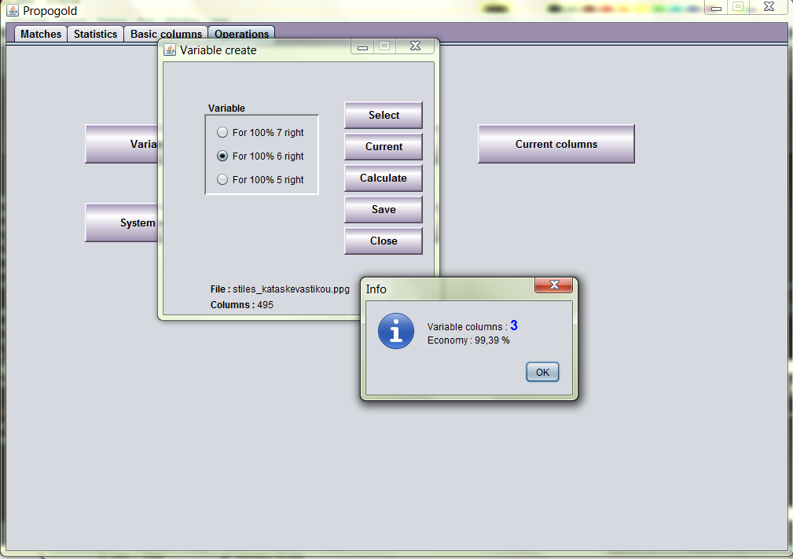

We have chosen the current columns, meaning 495 columns. We have selected ‘For 100% 6 right’ and hit ‘Calculate’. Algorithm run and we have a result of only 3 columns. What this means is, that we may have a set of only 3 columns out of 495, that guarantees us 6 right predicted, if we get all 8 in the system of 12 chosen number.

Of course, since the algorithm running is a greedy algorithm, may not be the best minimum set.

Then we are able to save our columns to a file. All column files, have an extension of .ppg. We save it as ‘mycolumns.ppg’. Now let’s open it up and view or print it.

We hit button “View – print file” and select ‘mycolumns.ppg’.

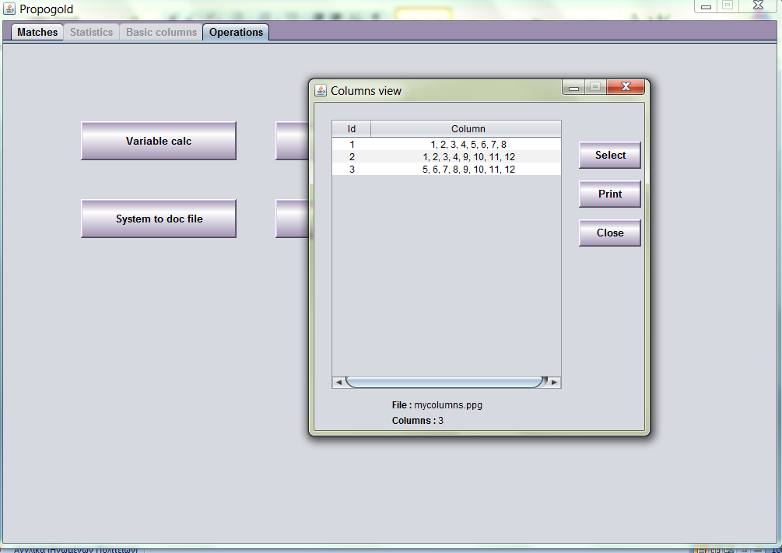

We see 3 columns. Let’s try and print them.

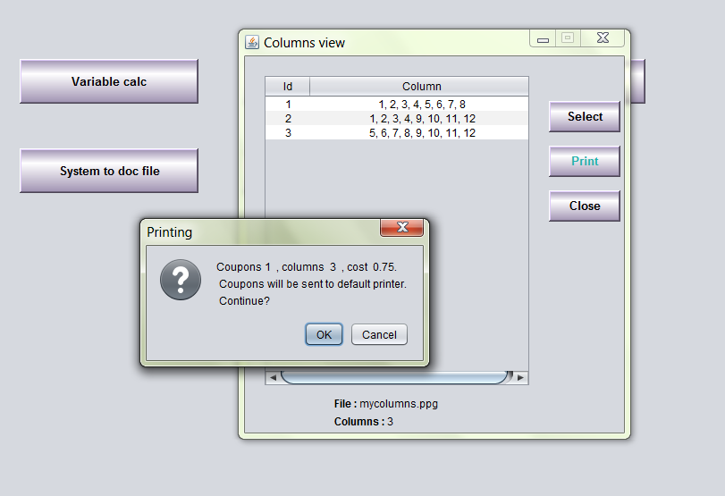

We get a message of Columns number, coupons needed and cost. If we continue, the columns will be printed by the default printer and look like that:

